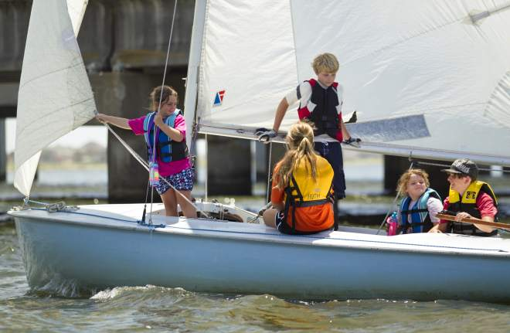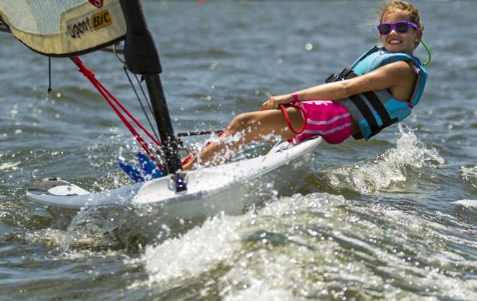
TAMMANY YACHT CLUB
2023 SUMMER CAMP
Session 1 - June 5th through June 16th
Session 2 - June 19th through June 30th
Session 3 – July 10th through July 21st
Learn to Sail for beginners and experienced campers, ages 7-16
Tammany Yacht Club is once again hosting its Summer Sailing Camp, with 3 sessions. Each session is two weeks long, Monday through Friday from 9am - 4pm.
FOR ALL INTERESTED CAMPERS; MEMBERS AND NON-MEMBERS WELCOME
AGES 7-16

Child/Family Member of TYC Member: $450 / 2-week session

Non-Member: $500 / 2-week session

We try to make our program as enjoyable as possible for the juniors, and as convenient as possible for the parents. For more info, visit our website under Sailing/Sail Camp, email us, or phone Tammany Yacht Club at 985-649-5222.

